CASE STUDY: CASEY HOLMES AND WAJ
Bridging cultural differences through friendship
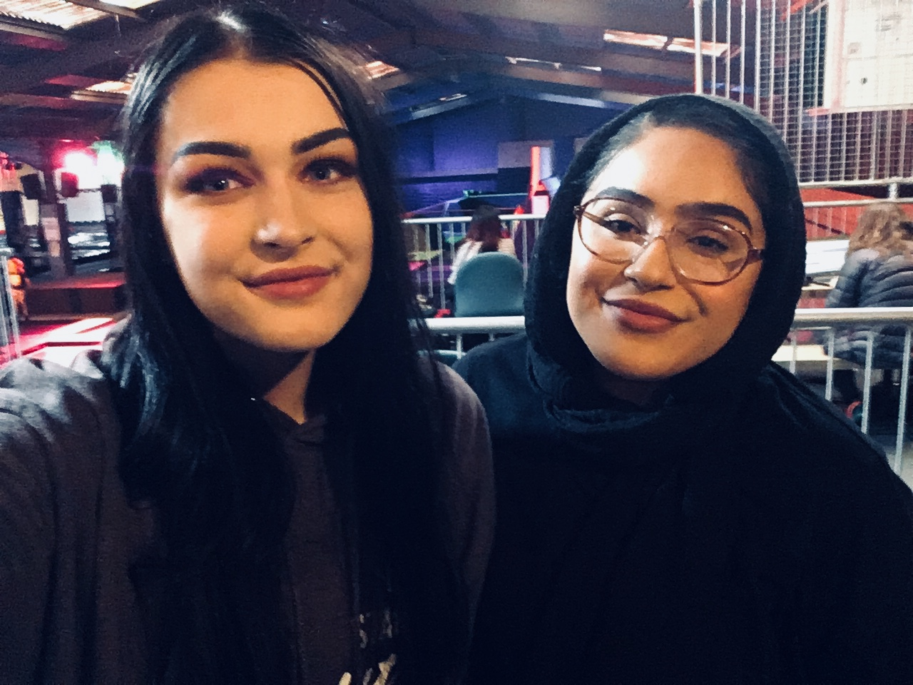
Casey and Waj, both from Rotherham in South Yorkshire, met on the National Citizen Service (NCS) programme in 2017. Despite coming from very different backgrounds, and living on opposite sides of town, they have since become firm friends.
“I’d never have met Waj were it not for NCS,” says 17-year-old Casey, who comes from a predominantly white British area of Rotherham. “We bonded during a massive hike up a mountain, and hit it off immediately.
“Where I’m from, it’s not ethnically diverse,” she explains. “I’d not really interacted with people from different backgrounds, so meeting Waj was a new experience. On NCS, there are so many different groups of people, but it gives you those commonalities and talking points. For example, I didn’t know the ins and outs of what Halal meat was until I met Waj, and I remember asking her about her hijab, and whether she wears it at home.
“I think there’s often a lack of understanding about different cultures. You don’t really learn about it in school, but being aware of and accepting other people’s cultures makes you a more rounded person.”
“To begin with, our conversation was mostly about our differences, which meant we learnt from each other,” agrees fellow NCS graduate Waj, 16. “People think difference will tear people apart, but it actually brings people closer together, and that’s powerful.
“Casey definitely learnt a lot about my culture, and she taught me to try more new things. She’ll give anything a go! Also, before I visited where she lives, I wouldn’t have been completely comfortable about going to a predominantly white area, in case there was some kind of hate there.
“Integration is really important,” continues Waj. “We’re such an ethnically diverse country, so it’s great when people get to meet people from different backgrounds, like at NCS. For me, having friends from different races and religions means you get to learn different things every day. It makes you more knowledgeable and well informed. And you get to try lots of different foods!”

About NCS
NCS is a government backed programme established in 2011 to help build a more cohesive, mobile and engaged society. By bringing together young people from different backgrounds for a unique shared experience, NCS helps them to become better individuals, and in turn better citizens.

NCS is open to 16 and 17 year-olds across England and Northern Ireland. The two to four week programme, which takes place in school holidays, includes outdoor team-building exercises, a residential for participants to learn ‘life skills’, a community-based social action project and an end of programme celebration event.

To date:
- Almost 500,000 young people have taken part
- Twelve million hours of community action have been completed
- For every £1 spent, NCS’ 2016 summer programme delivered between £1.15 and £2.42 of benefits back to society
It costs participants just £50 or less to take part in NCS and bursaries are available on a case by case basis. Support is provided for young people with additional needs.

To find out more visit NCSyes.co.uk.

About NCS Trust
National Citizen Service Trust is a not-for-profit organisation incorporated by Royal Charter and established to shape, support, champion and lead a thriving National Citizen Service.

National Citizen Service Trust is registered in England and Wales with Royal Charter Body number RC000894. Our registered office is at The Pembroke Building, Kensington Village, Avonmore Road, London, W14 8DG.

