CASE STUDY: USMAN AHMED

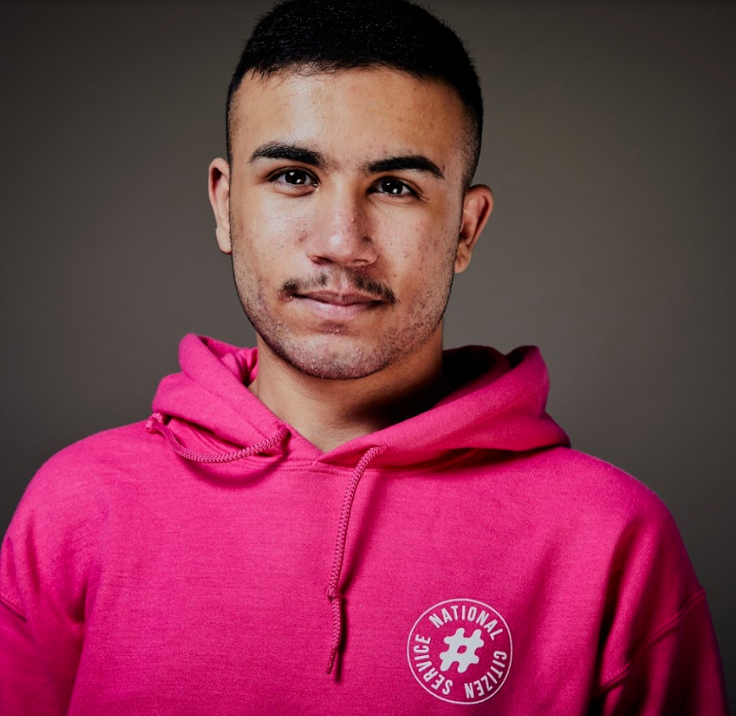
Why we need to conquer hate crime

Usman Ahmed is a 19 year old from Luton, who has been a personal victim of hate crime in the UK. With the rising levels of hate crime reported by The Home Office this morning, Usman would like to share his personal story of how hate crime has affected him personally, how it inspired him to start his own project combating hate crime, and how we can continue to overcome it.

“I live and grew up and Luton, a town situated 30 miles Northwest of London. Luton is known today as a town made up of a diverse mix of religions and cultures, with the demographic being made up of white British, Asian, Middle Eastern,Polish and Roma people. Despite everyone considering Luton their home - tensions between the groups from different ethnic backgrounds exist, making it hard for some people to integrate and feel part of a wider community.

“Having grown up here as a young Muslim boy, I was always aware of these divisions. The English Defense League (EDL) was founded and operates quite heavily in the area, preaching Islamophobia and stirring up tensions between people in the community. They were constantly encouraging people to alienate and turn against their Muslim neighbours. Growing up, I regularly witnessed members of the EDL running through the streets of Luton and the violence and panic it would spread among people.

“Over the last few years I feel like Islamophobia has been getting worse, just from speaking to family members and friends who have experienced it in day to day life. I think many events have been a catalyst for this, especially the refugee crisis in 2015 and the Brexit decision a year later, which heightened the divisions felt in many communities made up of people from a mixture of backgrounds. I’m therefore not surprised that figures released by the Home Office today have found that levels of hate crime have continued to rise in the UK.

“It was two years ago that I had my first personal experience of hate crime. In May 2016 I was standing outside the local police station in Luton, when someone drove past and shouted ‘YOU ISIS C*NT’ at me. At first I was shocked and then confused as nothing like this had never happened to me before. But the more I thought about it, the angrier I got; what had I done to deserve this? Not long after after a boy at my school threw a piece of pepperoni at me, in an attempt to mock my religion.

“These events affected family as well. My parents became increasingly worried about my safety and whereabouts. For me these things are a bit of a self-fulfilling prophecy: if a certain group is made to feel like they don’t belong in the community then divisions grow and hatred on both sides will intensify.

“These personal events, alongside what I could see happening on a day to day bases, impacted me so much that it inspired me to start my own community project: ‘The Hate Crime Project’ where I teach young people about the 5 different signs of hate crime. The project aims to build awareness and give them the skills to go into communities and educate others about it. Hate crime isn’t just about physical abuse, it’s about alienating another person because of their religion, disability, sexual preference or any other prejudice. The idea for this project came to me following my involvement in the National Citizen Service (NCS) at 16.

“NCS is a programme that takes place in summer holidays which is designed to encourage social mixing and inclusion, as well as engaging young people around issues in their communities. The part of NCS that I enjoyed the most was the social action project, where groups are empowered to tackle social issues in their communities. NCS was the first time that I experienced different people from my community coming together to campaign with common purpose. I enjoyed it so much that I decided I wanted to work for the programme when I was 19 and so spent my summer holidays doing so.

“During my time as an team leader, I really saw how programmes like NCS can break down social barriers. Independent research has found that those from the most segregated communities prior to participating, became almost a fifth more likely to report positive social contact with other ethnic groups ‘quite often’ or ‘very often’ after completing the programme.

“In one of my teams, I had a boy who was Asian and one which was White-british. Throughout their time on the programme, they used NCS as a safe space to ask questions about each other's cultures. Things like how people fast during Ramadan, and why women wear headscarves were all able to be an open discussion without hostility. Social integration doesn’t just happen - we need to provide the opportunities for young people to meet and mix with people different to them to get a better understanding of one another.

“One of the best things about Luton is its diversity and I believe it’s extremely important to make sure people feel safe and welcomed. By encouraging young people to take part in programmes like NCS and working together to overcome hate crime I believe we can build a society that benefits everyone.”

About NCS
NCS is a government backed programme established in 2011 to help build a more cohesive, mobile and engaged society. By bringing together young people from different backgrounds for a unique shared experience, NCS helps them to become better individuals, and in turn better citizens.

NCS is open to 16 and 17 year-olds across England and Northern Ireland. The two to four week programme, which takes place in school holidays, includes outdoor team-building exercises, a residential for participants to learn ‘life skills’, a community-based social action project and an end of programme celebration event.

To date:
- Almost 500,000 young people have taken part
- Twelve million hours of community action have been completed
- For every £1 spent, NCS’ 2016 summer programme delivered between £1.15 and £2.42 of benefits back to society
It costs participants just £50 or less to take part in NCS and bursaries are available on a case by case basis. Support is provided for young people with additional needs.

To find out more visit NCSyes.co.uk.

About NCS Trust
National Citizen Service Trust is a not-for-profit organisation incorporated by Royal Charter and established to shape, support, champion and lead a thriving National Citizen Service.

National Citizen Service Trust is registered in England and Wales with Royal Charter Body number RC000894. Our registered office is at The Pembroke Building, Kensington Village, Avonmore Road, London, W14 8DG.

