CASE STUDY: JAMES WATSON

Gaining the confidence to speak out on LGBT+ and gender stereotyping

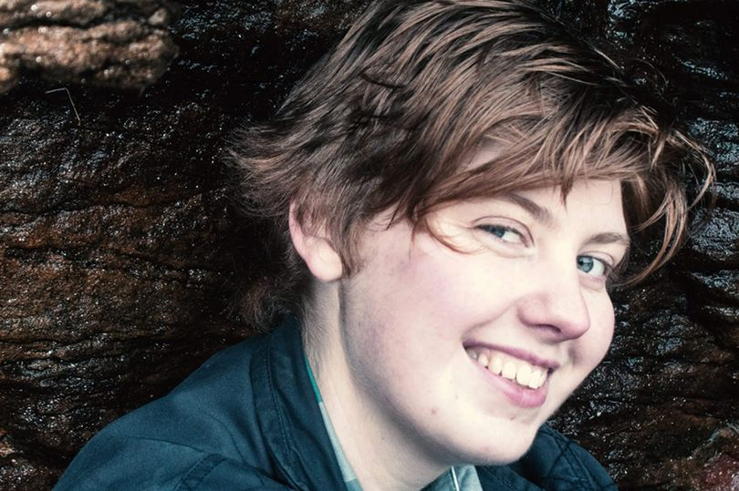

James Watson, 19, was born female but spent his childhood shunning feminine stereotypes - strongly believing he should have been born a boy. From six years old James would wake up crying, after dreaming about being a boy and waking up to realise he was still Jemma.

All through his life, James has had the pressure of gender stereotypes to contend with, as he struggled with his own identity and coming to terms with who he really wanted to be. Unknowingly, his parents were no different and had through James’ childhood tried to encourage him to be more girly. This led to James hiding his new identity from his parents for months, when he started afresh as James at university.

“I’ve only just officially come out this year (2018)” said James, “I knew that I was transgender from a young age, but I wasn’t ready to tell anyone.

“Coming out is hard whether it’s as trans or gay. Both female and male stereotypes in my opinion are not needed and are more harm than they are good.

“I have female friends who are the strongest people I know. They play football, which is still popularly seen as a man’s sport, but who can also get dressed up and fit into the so-called norm for girls. Male stereotypes are just as bad as it’s perceived that men have to be strong and show no sad emotions, or even cry. This has already been shown to have a negative effect on mental health.

“From a young age we are exposed to gender expectations in film, on TV and now across social media. Gender stereotypes are consistently reiterated to us – how we’re supposed to be, how we’re supposed to act as a girl or boy, how we’re supposed to look and what we’re supposed to wear, to be considered as normal.

“Fortunately for me, I have friends and met people who were very supportive and encouraged me to be who I wanted to be. It was actually on the National Citizen Service (NCS) summer programme in 2016 that I started to develop the confidence and support network I needed to finally come out.

“I remember a girl, who I didn’t know, stand up in front of the entire cohort and came out as bi-sexual. From that moment we formed a connection and started to talk with her about how she gained the confidence to tell everyone. And she’s still someone I speak to regularly for support. At first I only told a few people I bonded with really well. When I told them, it felt natural and they were supportive from the get-go, and they are still part of my support network now.

“People share their support in a variety of ways: from encouragement from friends, and NCS staff who automatically changed my name and gave me the assurances that I was surrounded by those I could trust, to doctors who provide medical support.

“After summer 2016, I got involved in other NCS programmes and met other young people from different areas who were going through similar experiences, something I wouldn’t have been able to do otherwise.

“The advice I’d give anyone is to be who you feel you are despite what others might think. This is your life, so do the things that make you happy. Don’t waste time pleasing others. If they love and respect you then they will support what makes you happy.

“Your life is important and being true to yourself is key to living a happy life. There will be times where it will feel like everyone is against you but remember that there are those that will be proud of how far you’ve come. Take life a step at a time and remember to celebrate the small achievements as well as the big ones.”

About NCS
NCS is a government backed programme established in 2011 to help build a more cohesive, mobile and engaged society. By bringing together young people from different backgrounds for a unique shared experience, NCS helps them to become better individuals, and in turn better citizens.

NCS is open to 16 and 17 year-olds across England and Northern Ireland. The two to four week programme, which takes place in school holidays, includes outdoor team-building exercises, a residential for participants to learn ‘life skills’, a community-based social action project and an end of programme celebration event.

To date:
- Almost 500,000 young people have taken part
- Twelve million hours of community action have been completed
- For every £1 spent, NCS’ 2016 summer programme delivered between £1.15 and £2.42 of benefits back to society
It costs participants just £50 or less to take part in NCS and bursaries are available on a case by case basis. Support is provided for young people with additional needs.

To find out more visit NCSyes.co.uk.

About NCS Trust
National Citizen Service Trust is a not-for-profit organisation incorporated by Royal Charter and established to shape, support, champion and lead a thriving National Citizen Service.

National Citizen Service Trust is registered in England and Wales with Royal Charter Body number RC000894. Our registered office is at The Pembroke Building, Kensington Village, Avonmore Road, London, W14 8DG.

