SAINSBURY’S ROLL OUT TEENS’ IDEA IN BID TO INSPIRE ONE MILLION FOOD BANK DONATIONS

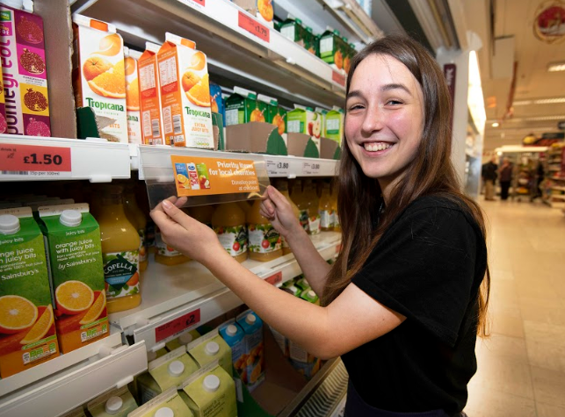

- Teenagers participating in National Citizen Service (NCS) tripled donations to their local food bank with one simple idea that supermarket giant Sainsbury’s is set to roll out nationwide
- The initiative involves putting stickers against priority food bank items to prompt customers during their shop to give to their local food bank
- The teens’ idea is being introduced across all Sainsbury’s stores to support its mission to ‘Help Brighten a Million Christmases’

This week, a group of 13 National Citizen Service (NCS) graduates from Exeter will see their simple idea to drive food bank donations rolled out in Sainsbury’s stores nationwide.

The idea - which is set to inspire one million donations over Christmas - was developed after the NCSers spoke to their local food bank during the social action phase of the national youth programme for 16 and 17 year olds.
NCS graduate, Holly Manning, 17, from Exeter, said: “After talking to the manager of our local food bank it was clear that shoppers were being reminded too late about donating, with food bank collection points usually being placed at the exit of the store. We also learnt that people were regularly donating similar items, making it difficult for them to get the quantity and variety that they needed to serve the needs of their beneficiaries.”
To combat this, the NCS grads came up with a simple, ingenious idea: pop a branded sticker alongside the items most needed by the local food bank to encourage people to purchase the item and drop it in the existing food bank collection box on their way out.
Holly continued: “Once we had developed an idea we were confident would help we set about pitching it to various local retailers. After being turned away by a few we popped into Sainsbury’s and spoke to the store manager who, to our delight, agreed to trial the initiative.”

After two weeks of the labels being in store, the food bank reported the number of donations had increased by 300%.

Mark Richardson, manager of Exeter foodbank, said: “Teenagers these days often have an unfair reputation for being unengaged with the world around them, so it’s great to see young people being empowered by programmes like NCS to go out into their communities and make a difference.

“The results of this initiative just goes to show that sometimes you just need a new mind on an old problem, sometimes the most simple ideas have the greatest impact. This campaign has already had fantastic results locally, and I’m excited to see how it can benefit food banks and their clients across the UK.”
The labels - which will appear alongside the top 15 priority food bank items all year round - will be a key driver in Sainsbury’s Supermarket and Sainsbury’s Argos’ festive food and toy donation drive: ‘Help Brighten a Million Christmases’.

Claudine Blamey, Sainsbury’s Group Head of Corporate Responsibility and Sustainability, said: “We’re excited to be working together as a Group to expand Sainsbury’s food donation programme and to launch Argos’ toy donation programme. We are committed to making a positive difference in local communities and we hope our customers get on board to help brighten the lives of those less fortunate in the community.
“It’s been brilliant to work with NCS graduates to permanently roll out their fantastic label initiative to all our stores and help reach our target of one million donations.”
To date, 12 million hours of social action have been completed by NCS participants and research has found that following the programme, NCS participants feel more able to have a positive impact on the world around them.

Michael Lynas, CEO at NCS Trust, said: “The first two phases of the NCS programme are designed to equip young people with the skills and confidence to make a difference, before we challenge them to design and deliver social action projects in phase three.

“Social action is such an important part of the NCS programme and it’s great to see young people thinking innovatively about how they can help their local community.

“We couldn’t be more proud of this group of young people for the impact they’ve already made in their local community, and the even bigger impact their idea is set to have across the country.”

- END -

Contact
For further information please contact:
NCS Media Team
media@ncstrust.co.uk

About NCS
NCS is a government backed programme established in 2011 to help build a more cohesive, mobile and engaged society. By bringing together young people from different backgrounds for a unique shared experience, NCS helps them to become better individuals, and in turn better citizens.

NCS is open to 16 and 17 year-olds across England and Northern Ireland. The two to four week programme, which takes place in school holidays, includes outdoor team-building exercises, a residential for participants to learn ‘life skills’, a community-based social action project and an end of programme celebration event.

To date:
- Almost 500,000 young people have taken part
- Twelve million hours of community action have been completed
- For every £1 spent, NCS’ 2016 summer programme delivered between £1.15 and £2.42 of benefits back to society
It costs participants just £50 or less to take part in NCS and bursaries are available on a case by case basis. Support is provided for young people with additional needs.

To find out more visit NCSyes.co.uk.

About NCS Trust
National Citizen Service Trust is a not-for-profit organisation incorporated by Royal Charter and established to shape, support, champion and lead a thriving National Citizen Service.

National Citizen Service Trust is registered in England and Wales with Royal Charter Body number RC000894. Our registered office is at The Pembroke Building, Kensington Village, Avonmore Road, London, W14 8DG.

